You will get below error with scala IDE. Note scla should be installed first.

<https://www.youtube.com/watch?v=aB4-RD_MMf0>

used above youtube video to get the information.

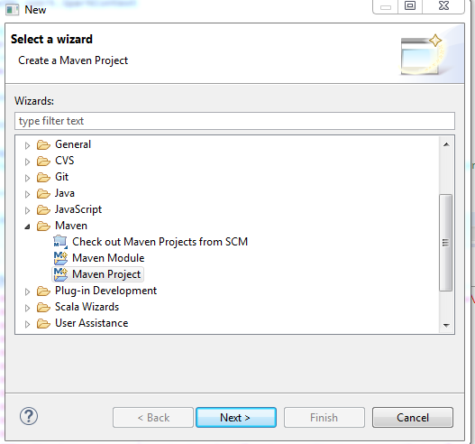

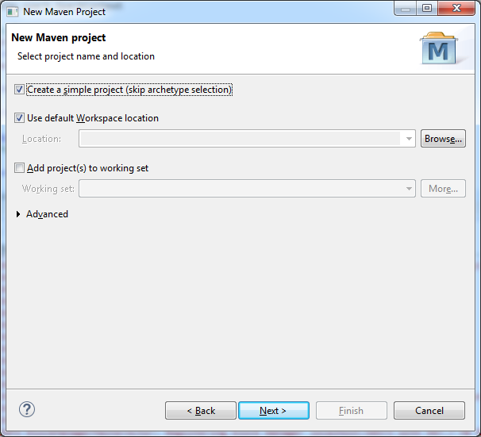

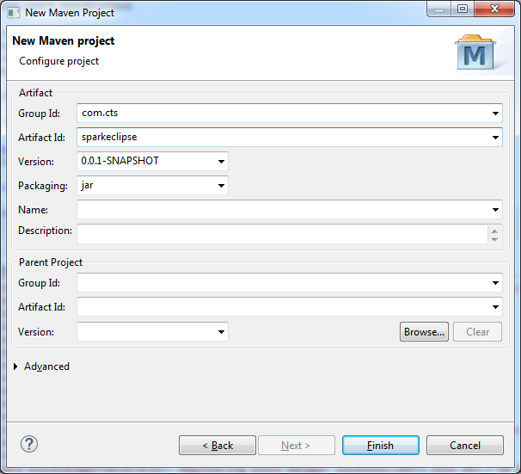

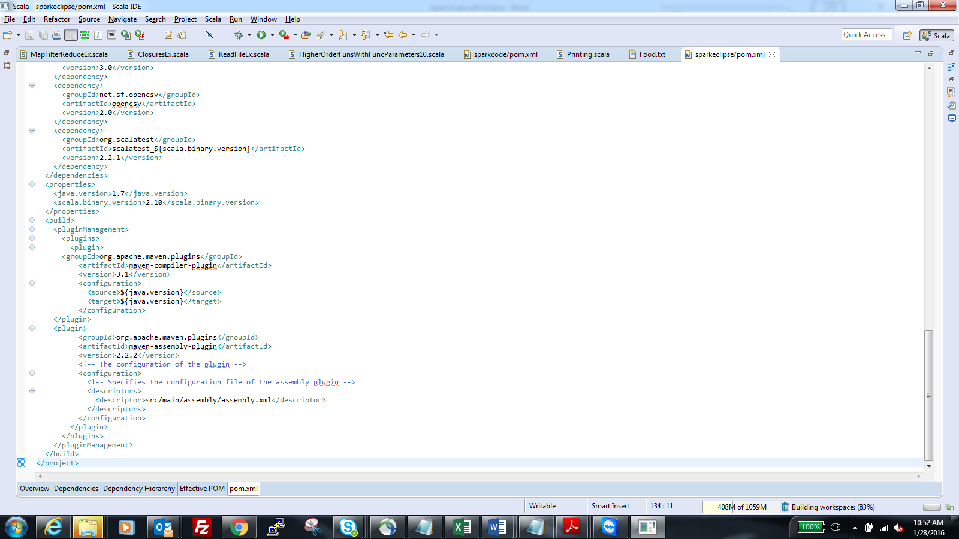

Copy Pom.xml entries from learning scala github repository.

You will get error in pom.xml in eclipse as shown below.

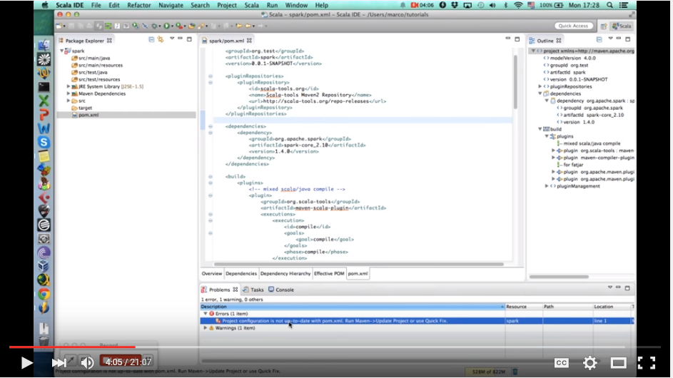

Right click on that and enter quick fix . At the window where is shown not on the file.

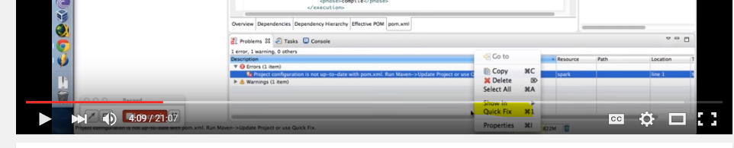

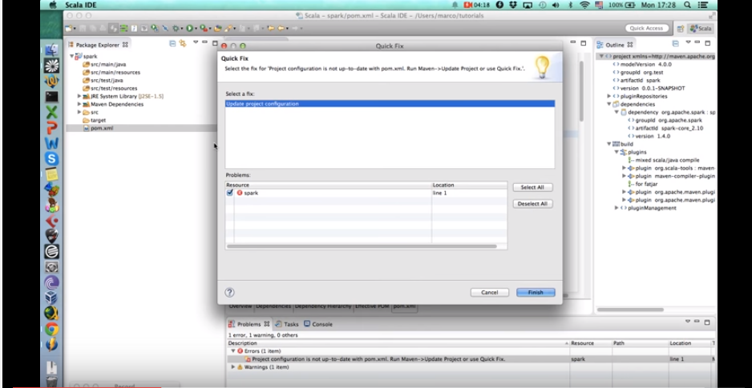

Add Scala Nature.

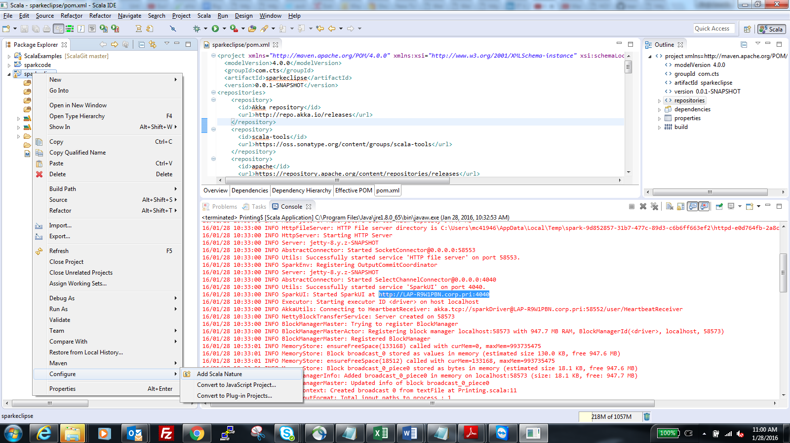

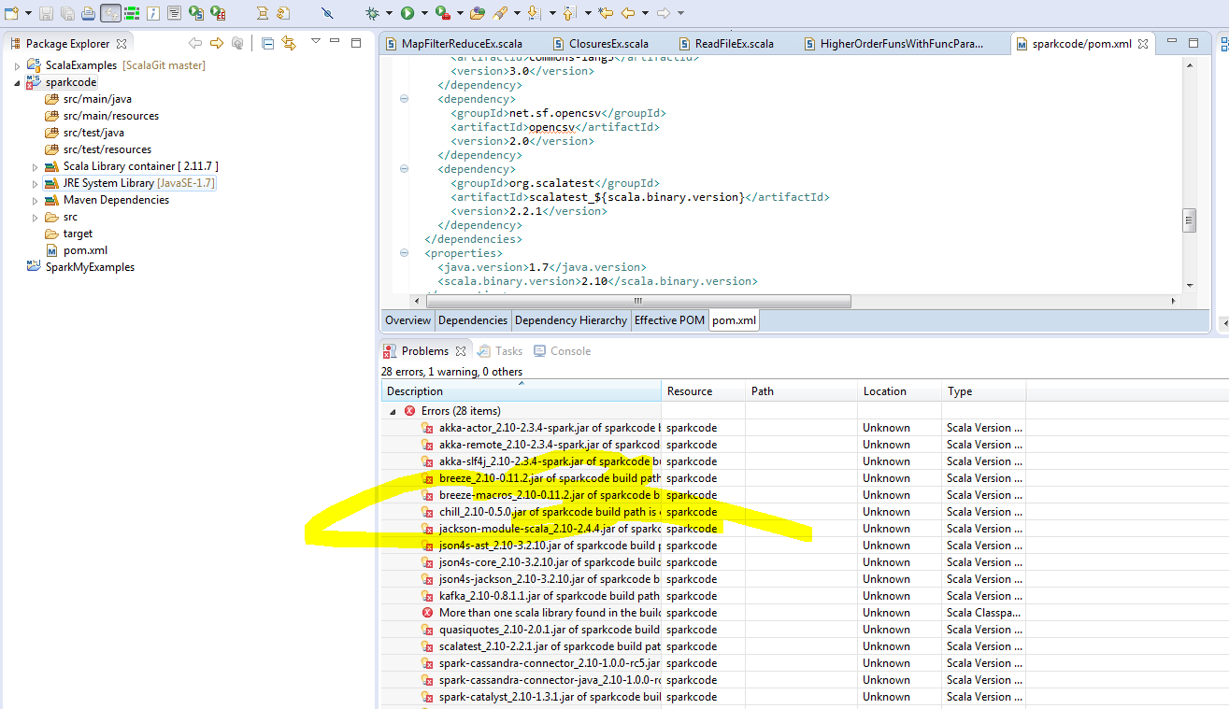

Errors will be removed after following steps highlighted in below screenshot.

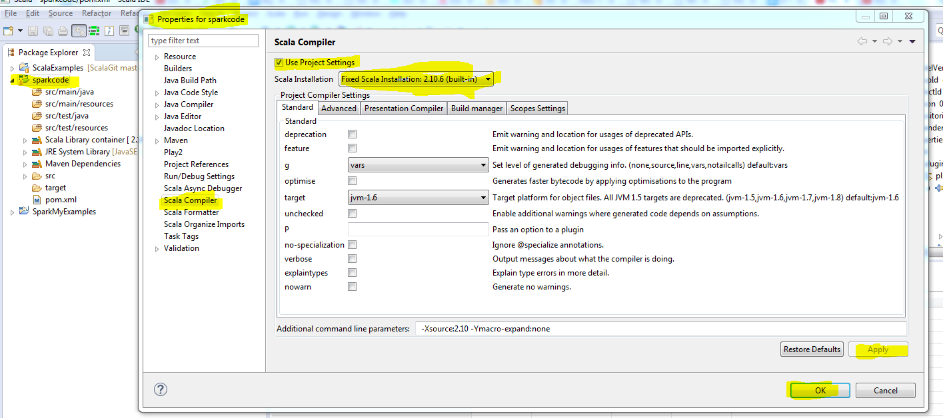

Remove scala library and then rename folders.

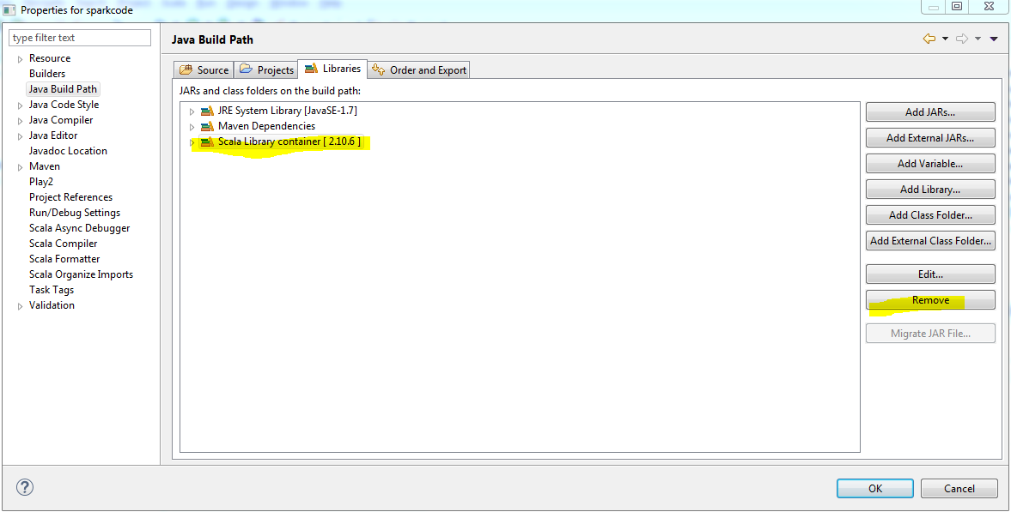

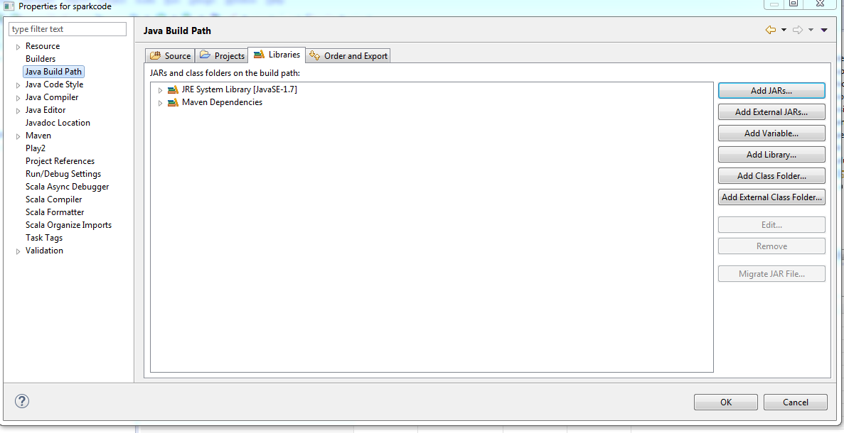

Rename java folders to scala in project.

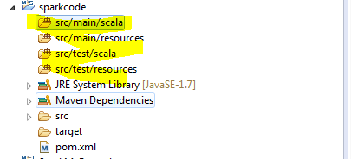

Create scala classes.

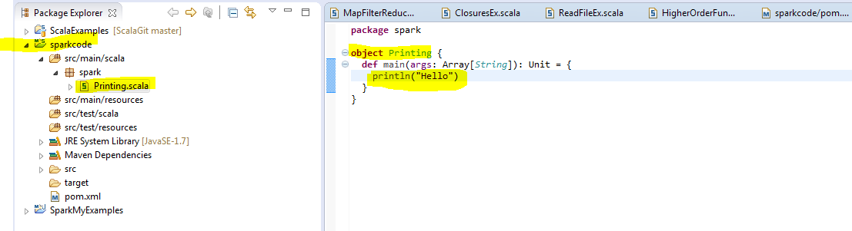

Run as Scala app after wiring code.

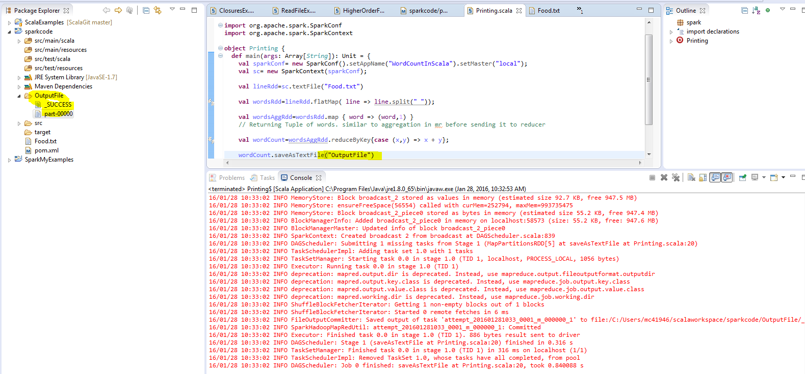

See the output in highlighted places.